**Instream flow requirements for the new license Middle Fork American River Project**

Kristen Podolak

Re: Can forest restoration “move the needle” on reservoir management objectives?

3.7.2017

**Background**

This is a summary of the flow requirements for flow releases from French Meadows Reservoir and Hell Hole Reservoir under the new FERC license application. I focused on environmental flows for Foothill yellow legged frogs as the two other sensitive instream species, hardhead and Western pond turtle, are found downstream of the Oxbow Powerhouse and are affected by the powerhouse peaking reach and SMUDs operations on the South Fork Rubicon River making consideration of these two species beyond the scope of this study (Figure 1). Whitewater boating flow releases occur downstream of the peaking reach below Oxbow Powerhouse and the confluence of the North Fork of the Middle Fork River, again outside of the scope of this study. The reservoir levels for recreational objectives are voluntary and not a requirement hence they are not included either.

**How would additional streamflow from forest fuels reduction benefit instream flow requirements/foothill yellow legged frogs?**

Hypothesis 1 – Increased streamflow during a below normal (BN), dry (D), critical (C), or extreme critical (EC) water year will help meet the higher minimum instream flow requirements and protect habitat for foothill yellow legged frogs.

Questions – How much more flow can be realized with the forest fuel reduction? Maybe look at the increase in flow from forest fuels reduction as a percentage of the annual flow to the reservoir during different water years. Would extra water make a difference?

The required minimum flows under the new license through a water year (Oct-Sept) are:

Below French Meadows Reservoir: EC/C (8-11 cfs), D (9-13 cfs), BN (10-13 cfs)

Below Hell Hole Reservoir: EC/C (15-31 cfs), D (20-35 cfs), BN (20-42 cfs)

Assumption – A lot of water is diverted from French Meadows Reservoir to Hell Hole Reservoir primarily for hydropower. Likely its more challenging to meet flow requirements below French Meadows Reservoir.

*This may not work in critical or extreme critical years when water needs to be released from the two reservoirs for water supply downstream. I can get these requirements if you don’t have them already. Additional water from forest fuels reduction may only be helpful in meeting instream flow requirements in below normal and dry years.

Hypothesis 2 - Increased streamflow during a wet (W) and above normal (AN) water year will help meet the increase pulse flow requirements and protect habitat for foothill yellow legged frogs.

Question – How many flow pulses could be met with additional streamflow?

Pulse flow requirements from May 15-June 5 are:

Below French Meadows Reservoir:

W May 15. Increase flows to a target mean daily flow of 200 cfs ± 10 percent.

W May 16. Increase flows to a target mean daily flow of 400 cfs ± 10 percent.

AN May 7. Increase flows to 200 cfs ± 10 percent.

AN May 8. Increase flows to 400 cfs ± 10 percent.

Below Hell Hole Reservoir:

W May 15. Increase flows to a target mean daily flow of 200 cfs ± 10 percent.

W May 16. Increase flows to a target mean daily flow of 400 cfs ± 10 percent.

AN May 7. Increase flows to 200 cfs ± 10 percent.

AN May 8. Increase flows to 400 cfs ± 10 percent.

Hypothesis 3 - Increased streamflow in wet and above normal water years will allow for higher initial down ramp spills and increase the opportunity for pulse flows from May to July in all other water year types (BN, D, C, and EC), protecting habitat for foothill yellow legged frogs.

Question – again how much more flow can be realized with the forest fuel reduction?

Middle Fork American below French Meadows Reservoir

≥400 cfs daily average flow spill requires down ramp schedule

Rubicon River below Hell Hole Reservoir

≥600 cfs Spill Event Down Ramp Schedule (if they occur)

*Need to discuss these hypotheses related to instream flow requirements and benefits to frogs with Sarah Yarnell and Ben Ransom and see where the value for instream flows seems realistic.*

*Need to discuss with project team to see how to quantify the benefit of additional water in the context of the instream flow requirements*

**Study area**

I would recommend we limit the study area to the French Meadows Reservoir and Hell Hole Reservoir watersheds, with inclusion of Duncan Creek watershed to the diversion point if we can get information on diversion flows. There are two stream gauges to use for this study area: Rubicon River below Hell Hole Dam (USGS Gage No. 11428800) and Middle Fork American River below French Meadows (USGS Gage No. 11427500). Both gauges can be used to model the historic hydrology in RHESSYs, up until September 30, 2015 for the Middle Fork American. The stream gauge below Hell Hole Reservoir will be used under the new license to monitor minimum instream flows for compliance with the license conditions until a new gauge is added.

**Instream flow requirements**

Below are the instream flow requirements listed in Placer County Water Agency’s application for a new 50-year license. This application was submitted to FERC on February 24, 2011 for continued operation and maintenance of the Middle Fork Project (FERC Project No. 2079) through February 28, 2063:

1. Higher minimum instream flow releases in the bypass and peaking reaches
2. Spring pulse flows in the bypass reaches
3. Modified ramping rates at Oxbow Powerhouse in the peaking reach
4. Cap on flow releases from Oxbow Powerhouse (Saturday of Memorial Day

weekend to Labor Day) in Dry, Critical, and Extreme Critical water years

1. Recreational flow releases in the peaking reach
2. Downramp of spill flows from May–July below Hell Hole Reservoir and French Meadows Reservoir
3. Modified minimum pool requirements in Hell Hole and French Meadows reservoirs
4. Consultation with representatives for the Tevis Cup and Western States 100 to

identify and provide flows suitable for adequate trail crossing conditions (when

flows are controllable by the Middle Fork Project)

Bypass reaches are sections of the river below reservoirs or diversions where operations result in the diversion of a portion of the water from that reach. These include the Middle Fork American River below French Meadows Reservoir and Rubicon River below Hell Hole Reservoir. In these reaches, flows are reduced and more stable during the winter/spring and equal to or greater than unimpaired conditions in the summer/fall to meet minimum instream flow requirements. The peaking reach refers to only one reach, the river below Oxbow Powerhouse, where flows fluctuate substantially to meet power demand or to support whitewater recreation. Summer/fall flows in the peaking reach are higher and more variable than unimpaired conditions.

The instream flow requirements have a minor effect on Project operations. The benefits of the instream flow requirements are, “power generation, consumptive water supply, system capability and reliability, public services, and resource stewardship.” (PCWA BA/BE, p. 4-38). One important change with the new license is an additional 7,600 acre feet of storage capacity in Hell Hole Reservoir due to the construction of 6 ft. high crest gates, called the Hell Hole Reservoir Seasonal Storage Increase Improvement project.

The instream flow requirements that apply to French Meadows Reservoir and Hell Hole Reservoir study area are (U.S. Forest Service 2012):

1. **Higher minimum instream flow releases in the bypass reaches**
2. **Spring pulse flows in the bypass reaches**
3. **Downramp of spill flows from May–July below Hell Hole Reservoir and French Meadows Reservoir**
4. **Modified minimum pool requirements in Hell Hole and French Meadows reservoirs**

All the flow requirements depend on the water year type. Water year types are classified based on forecasts or estimates of the American River unimpaired flow downstream of Folsom Reservoir. Below are the water year types, which occur during the water year Oct. 1-Sept. 30 based on the California Department of Water Resources (Bulletin 120 Forecast) for the time periods June1-October 31 and March 15-May 31 or California Department of Water Resource’s estimated Full Natural Flow record (California Data Exchange Center, AMF sensor 65) for the period from Nov. 1-March 14.

Tables from U.S. Forest Service (2012), p. 12

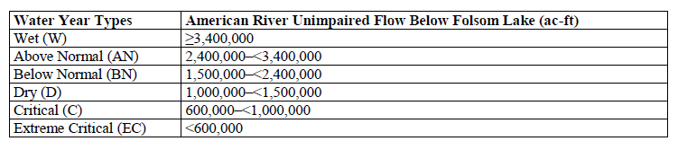

The implementation of the instream flow requirements under the new license go into effect when the infrastructure (outlet works) is completed. This ranges from within 30 days of the license issuance through six years after the issuance for the pulse flows and down ramp of spill flows from Rubicon River below Hell Hole Reservoir. For the purposes of this study, given that forest fuels reduction efforts will likely not be entirely completed in the next six years, it seems safe to assume all the new license infrastructure upgrades will be completed and all instream flow requirements can be implemented when any additional water would be supplied. The reservoir minimum pool requirements can already be implemented with the current water infrastructure.

Below are the instream flow requirements based on water year type that apply to our study area:

1. **Higher minimum instream flows in the bypass reaches**

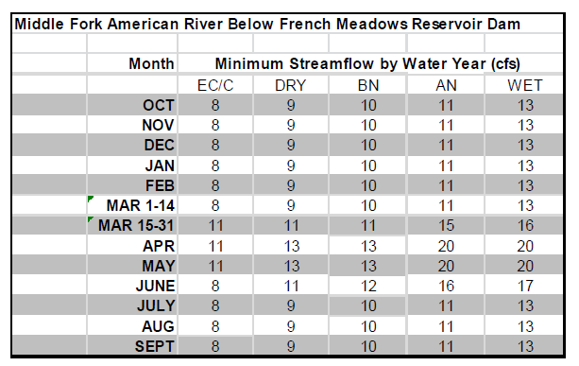

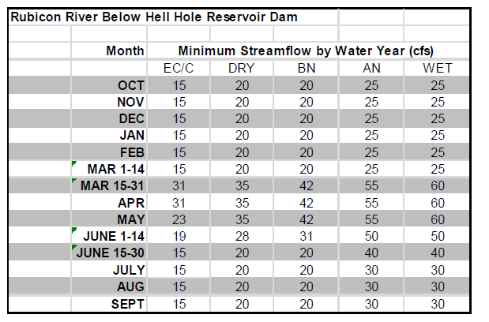

1. **Spring pulse flows in the bypass reaches**

Middle Fork American below French Meadows Reservoir – using only post Year 2 requirements

Wet Water Years After Year 2

May 15. Increase flows from the minimum streamflow release to a target mean daily flow of 200 cfs ± 10 percent.

May 16. Increase flows to a target mean daily flow of 400 cfs ± 10 percent.

May 24. Reduce the flow to a target mean daily flow of 275 cfs ± 10 percent.

May 26. Reduce the flow to a target mean daily flow of 190 cfs ± 10 percent.

May 29. Reduce the flow to a target mean daily flow of 115 cfs ± 10 percent.

June 1. Reduce the flow to a target mean daily flow of 65 cfs ± 10 percent.

June 5. Release minimum streamflow requirement.

Above Normal Years After Year 2

May 7. Increase flows from the minimum streamflow release to a target mean daily flow of 200 cfs ± 10 percent.

May 8. Increase flows to a target mean daily flow of 400 cfs ± 10 percent.

May 10. Reduce the flow to a target mean daily flow of 275 cfs ± 10 percent.

May 12. Reduce the flow to a target mean daily flow of 190 cfs ± 10 percent.

May 15. Reduce the flow to a target mean daily flow of 115 cfs ± 10 percent.

Rubicon River below Hell Hole Reservoir – beginning in year 6

Wet Water Years

In Wet water years pulse flows will be provided according to the following schedule:

May 15. Increase flows from the minimum streamflow release to a target mean daily flow of 200 cfs ± 10 percent.

June 21. Reduce the flow to a target mean daily flow of 150 cfs ± 10 percent.

June 23. Reduce the flow to a target mean daily flow of 90 cfs ± 10 percent.

June 26. Release minimum streamflow requirement.

Above Normal Water Years

In Above Normal water years pulse flows will be provided according to the following schedule:

May 1. Increase flows from the minimum streamflow release to a target mean daily flow of 200 cfs ± 10 percent.

May 16. Reduce the flow to a target mean daily flow of 150 cfs ± 10 percent.

May 18. Reduce the flow to a target mean daily flow of 90 cfs ± 10 percent.

May 21. Release minimum streamflow requirement.

1. **Down ramping of spill flows from May–July below Hell Hole Reservoir and French Meadows Reservoir**

Middle Fork American below French Meadows Reservoir

≥400 cfs daily average flow spill in the months of May through July requires down ramp schedule

Day 1. Release a target mean daily flow flow of 400 cfs

Day 2. Reduce the flow to a target mean daily flow of 275 cfs ± 10 percent.

Day 3. Reduce the flow to a target mean daily flow of 190 cfs ± 10 percent.

Day 4. Reduce the flow to a target mean daily flow of115 cfs ± 10 percent.

Day 5. Reduce the flow to a target mean daily flow of 65 cfs ± 10 percent.

Day 7. Release minimum streamflow requirement.

Rubicon River below Hell Hole Reservoir

≥600 cfs Spill Event Down Ramp Schedule (if they occur)

Day 1. Reduce the daily flow setting to 400 cfs.

Day 3. Reduce the daily flow setting to 285 cfs.

Day 6. Reduce the daily flow setting to 170 cfs.

Day 10. Reduce the daily flow setting to 95 cfs.

Day 14. Release minimum streamflow requirement.

1. **Modified minimum pool requirements in Hell Hole and French Meadows reservoirs**

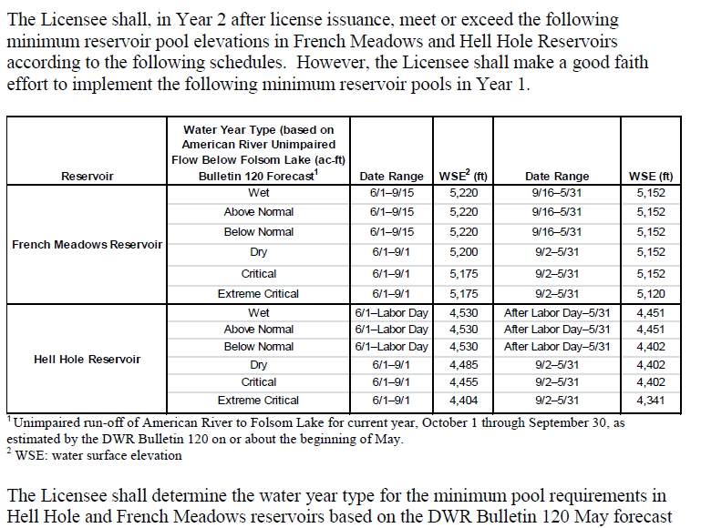

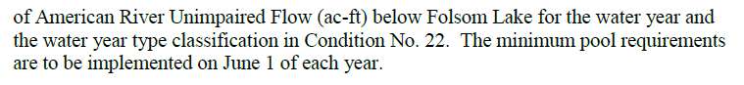

**References**

Placer County Water Agency. Draft. Application for New License, Middle Fork American River Project (FERC Project No. 2079), Biological Assessment/Biological Evaluation. Link provided by Marie Davis with PCWA

U.S. Forest Service. Nov. 29, 2012. Forest Service final conditions and recommendations provided unnder 18 CFR § 4.34 (b)(1) In Connection with the Application for Relicensing for the Middle American River Project (FERC No. 2079). Pdf provided by Ben Ransom with PCWA

Never could find this…

Placer County Water Agency (PCWA). 2011g. Instream Flow and Reservoir Minimum Pool Measure. Available in PCWA’s Application for New License – Supporting Document A.

**Additional Information**

Sensitive species impacted by flows from French Meadows Reservoir and Hell Hole Reservoir

* Fish = hardhead (*Mylopharodon conocephalus*) The pattern of hardhead distribution in the study area is primarily indicative of water temperature (Exhibit E – Section 7.5, Figure 7.5-2; and BA/BE Map 8) and fish barriers (Exhibit E – Section 7.5.8.2, Fish Passage Barriers). Hardhead were patchily distributed (Exhibit E – Section 7.5, Figure 7.5-2) and only observed in a few locations. The majority of the hardhead were found in Ralston Afterbay and the Middle Fork American and Rubicon rivers immediately upstream of Ralston Afterbay.
* Amphibian = Foothill yellow-legged frog (*Rana boylii*) **5.3.2.5 Foothill Yellow-Legged Frog** FYLF were dispersed widely throughout the study area in varying densities depending on stream size, flow regulation, and water temperatures (BA/BE Map 11). Abundance was highest in the downstream reaches of the Rubicon River and in comparison reaches and tributaries. Abundance was low in the Middle Fork American River bypass reach upstream of Ralston Afterbay, and individuals were observed rarely in the Middle Fork American River peaking reach.
* Reptile = Western pond turtle (*Ermy marmorata marmorata*) Eight WPT turtles were observed during the 2007 CRLF, FYLF, and fish populationsurveys (AQ 12 – TSR [PCWA 2011ff; SD B]). Six of these observations were in theMiddle Fork American River or tributaries downstream of Ralston Afterbay (peakingreach) and two were in the North Fork American River (comparison river not affected by

the MFP).

“The Project consists of two major storage reservoirs, two medium

regulating reservoirs, three small diversion pools, and five powerhouses that began

operation in 1967. The Project’s major storage reservoirs, French Meadows and Hell

Hole, have a combined capacity of 342,583 acre-feet (ac-ft). The Project has a total

dependable generation capacity of 223.7 megawatts (MW) and has an average annual

energy production of 1,039,078 megawatt-hours (MWh).” P. 1-1 (01_BA-BE file folder, Draft Biological Assessment/Biological Evaluation)

Details on the EXISTING hydropower facilities and reservoir outlets and diversions

4.1.1.1 Large Dams and Reservoirs

4.1.1.4 Water Conveyance Systems

4.1.1.5 Powerhouses

CHANGES TO RESERVOIRS under new license

4.2.1.1 Large Dams and Reservoirs (p. 4-41)

• French Meadows Dam Outlet Works (modified)

French Meadows Dam Outlet Works will be modified as part of the French

Meadows Outlet Works Modification to provide and monitor new MIFs, pulse

flows, and downramp or spill flow requirements under the Proposed Action. In

addition, two new gages will be installed to monitor compliance with instream

flow requirements.

• Hell Hole Dam Outlet Works (modified)

Hell Hole Dam Outlet Works will be modified as part of the Hell Hole Dam Outlet

Works Modification to provide and monitor new MIFs, pulse flows, and downramp

or spill flow requirements under the Proposed Action. Hell Hole Dam will be

modified as part of the Hell Hole Reservoir Seasonal Storage Increase

Improvement by adding 6-foot-high crest gates on the existing Hell Hole Dam

Spillway. These crest gates may be raised under certain conditions to increase

Hell Hole Reservoir storage.

4.2.1.4 Water Conveyance Systems

The Proposed Action has no new or modified water conveyance systems .

4.2.1.5 Powerhouses

The Proposed Action has no new or modified powerhouses.

Figure 1. Foothill yellow legged frog (a), Western pond turtle (b), and hardhead habitat, downstream of Oxbow powerhouse due to natural fish barriers (c) from PCWA Draft. Western pond turtle and hardhead occur below the confluence of the Middle Fork American River and the Rubicon River, hence the flow impacts for these two species would require consideration of Oxbow Powerhouse and is beyond the scope of this study. We focused on the impacts to Foothill yellow legged frogs from any increase in water due to forest fuel reduction activities.

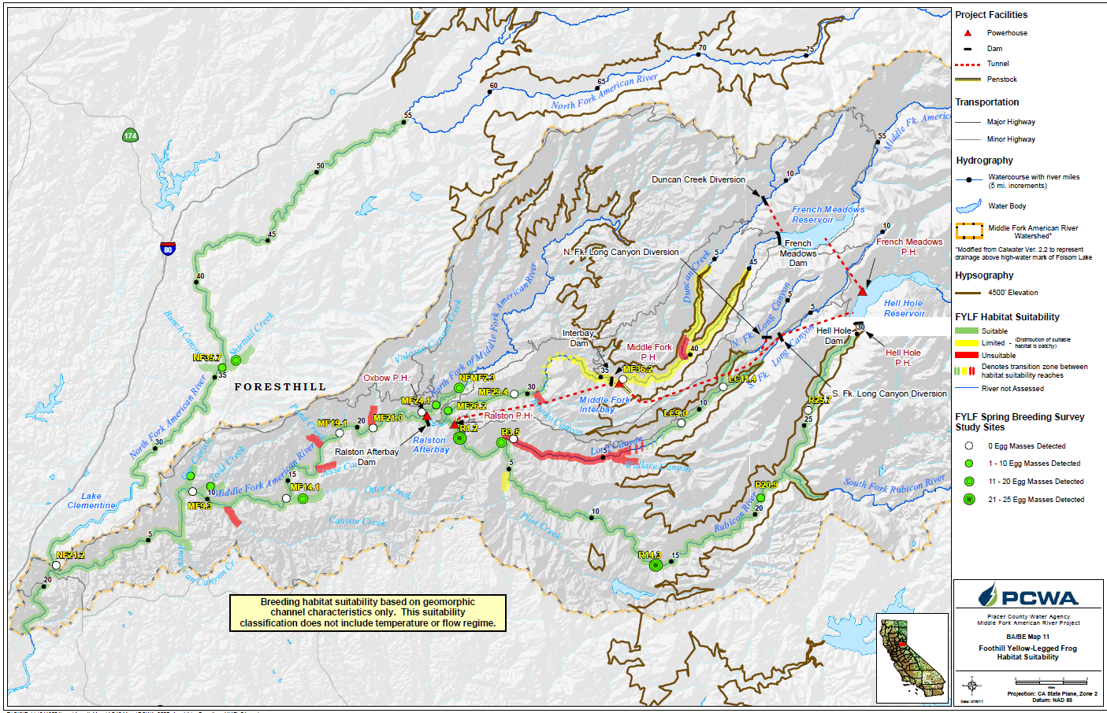

(a)

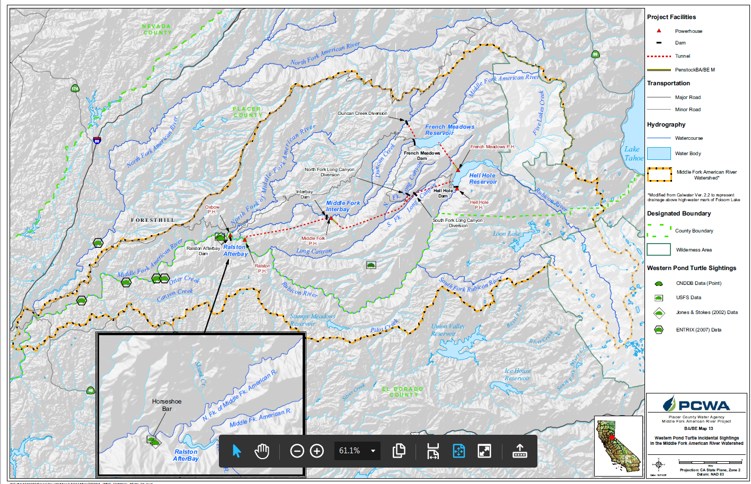

(b)

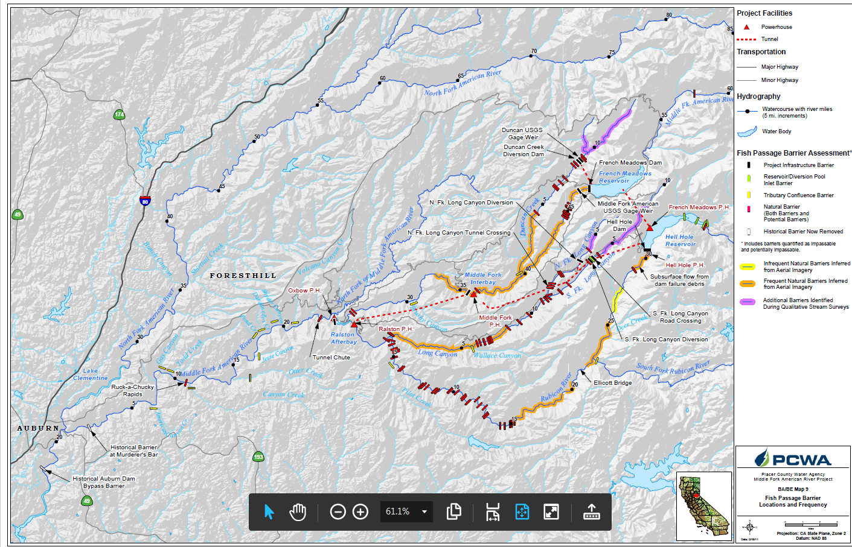

(c)